
https://unsplash.com/photos/LFZmG18SgCM Photo by Joshua Clay
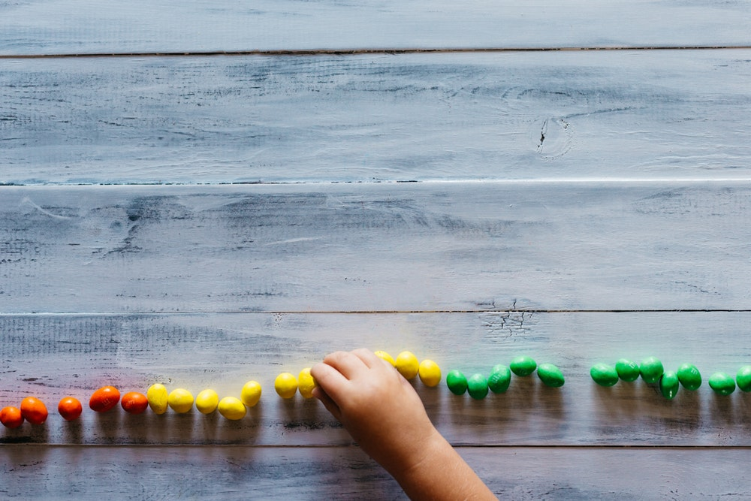
https://unsplash.com/photos/vHn0JnxFMP8 Patrick Fore

https://unsplash.com/photos/XKpPsuuGE_Q Lubomirkin


https://unsplash.com/photos/8IUZi-pUph8 Kelly Sikkema


https://unsplash.com/photos/JZ51o_-UOY8 Daiga Ellaby

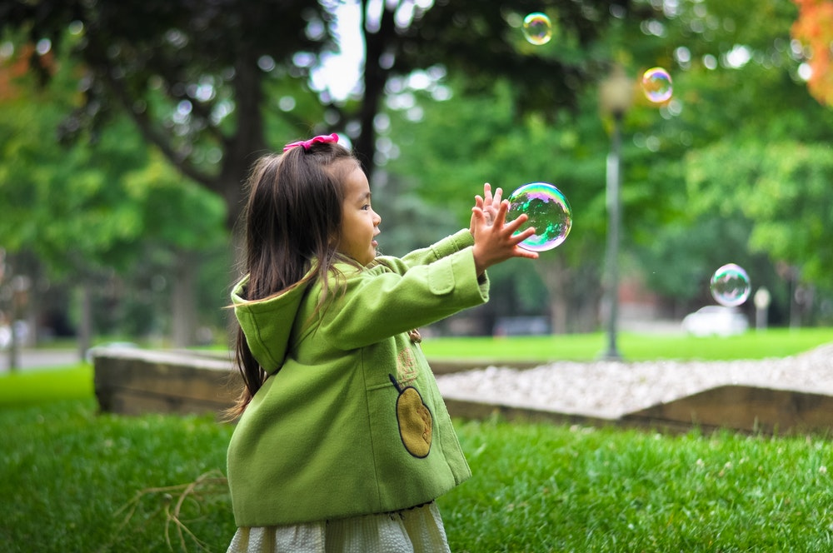
https://unsplash.com/photos/wtxcaDIdOCM Leo Rivas
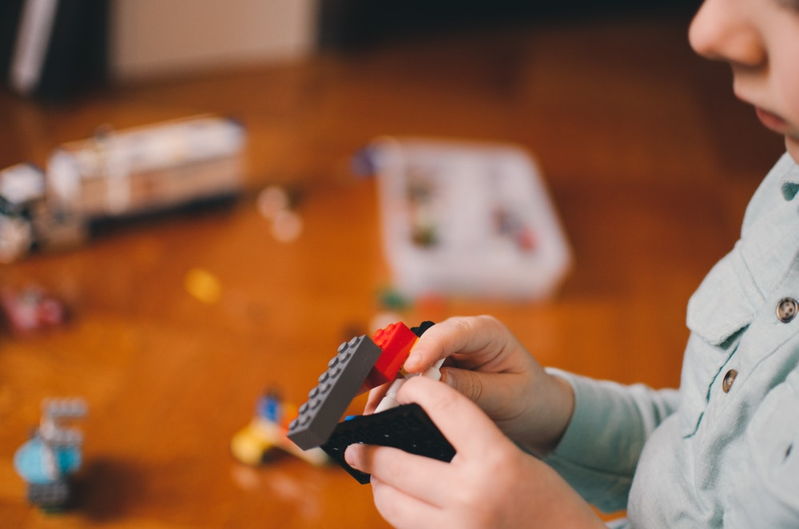
https://unsplash.com/photos/JRVxgAkzIsM Kelly Sikkema

https://unsplash.com/photos/geNNFqfvw48 Michal Parzuchowski
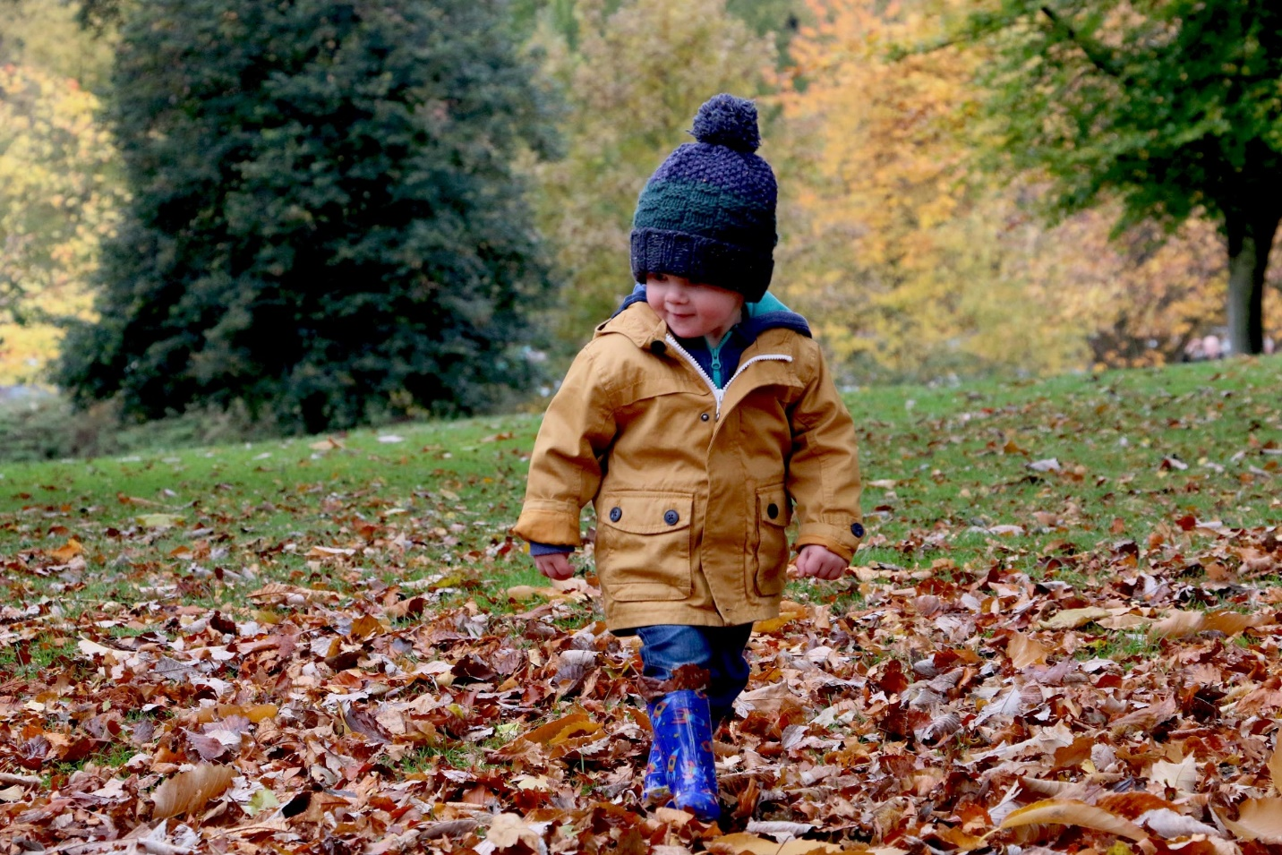
Michael podger
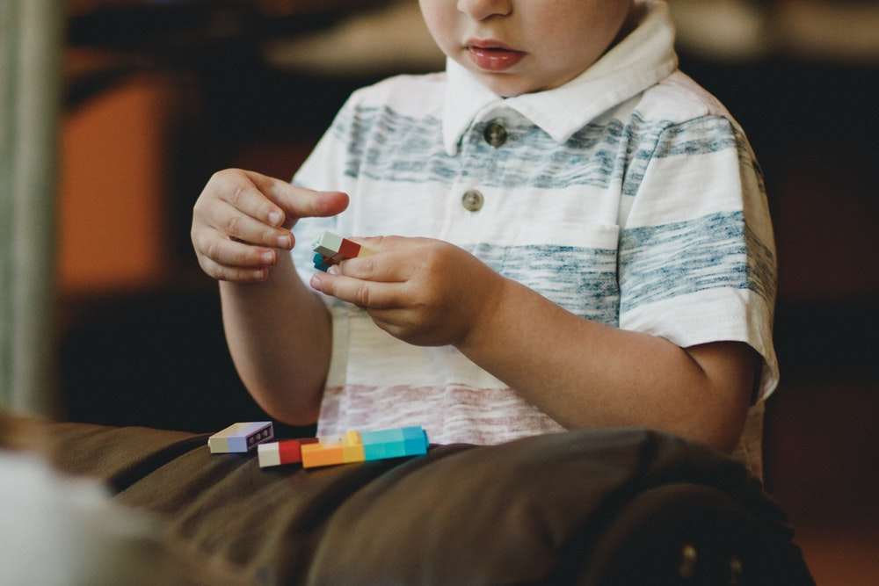
https://unsplash.com/photos/ecRuhwPIW7c Caleb Woods
To see the brain at work, head for the hands.

https://unsplash.com/photos/gZlsrMPwz0o Alexander Dummer
Used Fig. 1.5 Eco-Ed Book

To see the brain tuned out, watch a formulaic lesson
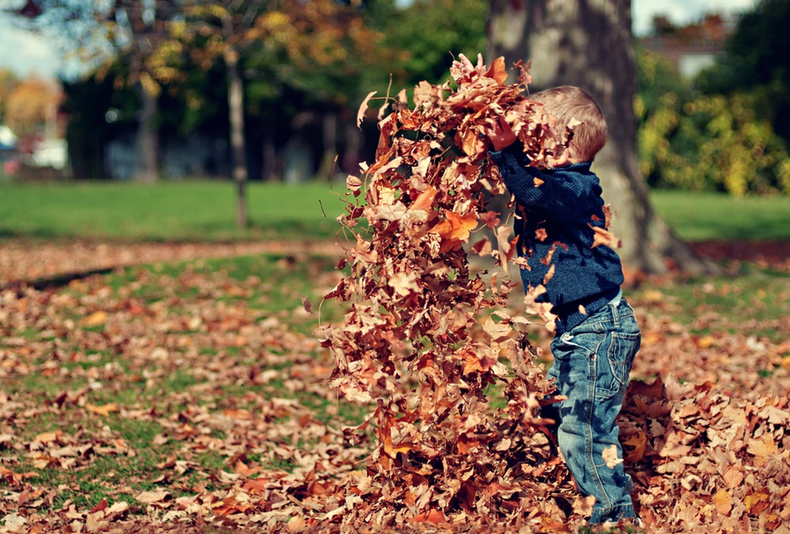
https://unsplash.com/photos/obKbq4Z3cuA Scott Webb

https://unsplash.com/photos/VNjNtdu0yCw Joshua Clay

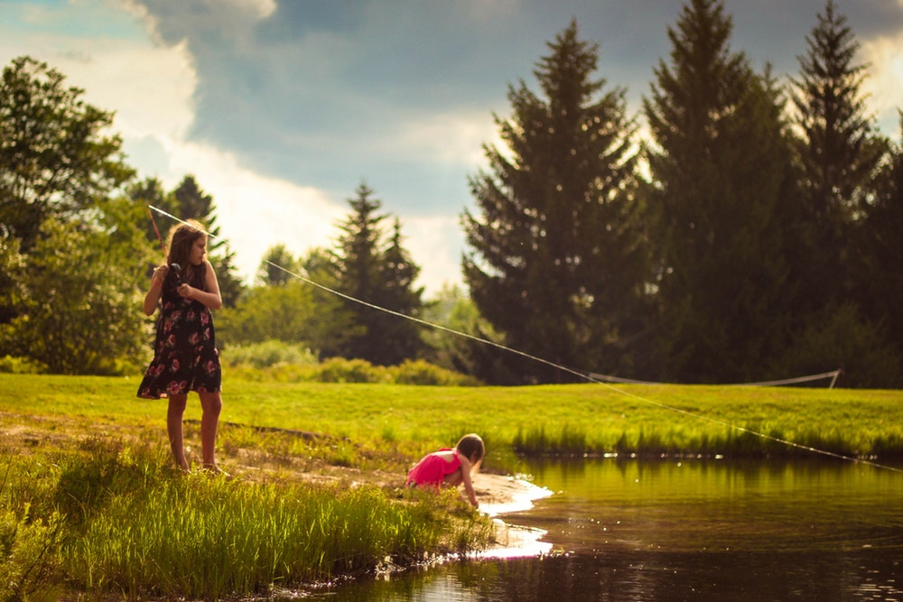
https://unsplash.com/photos/QC7tbiujK04 Luke Brugger
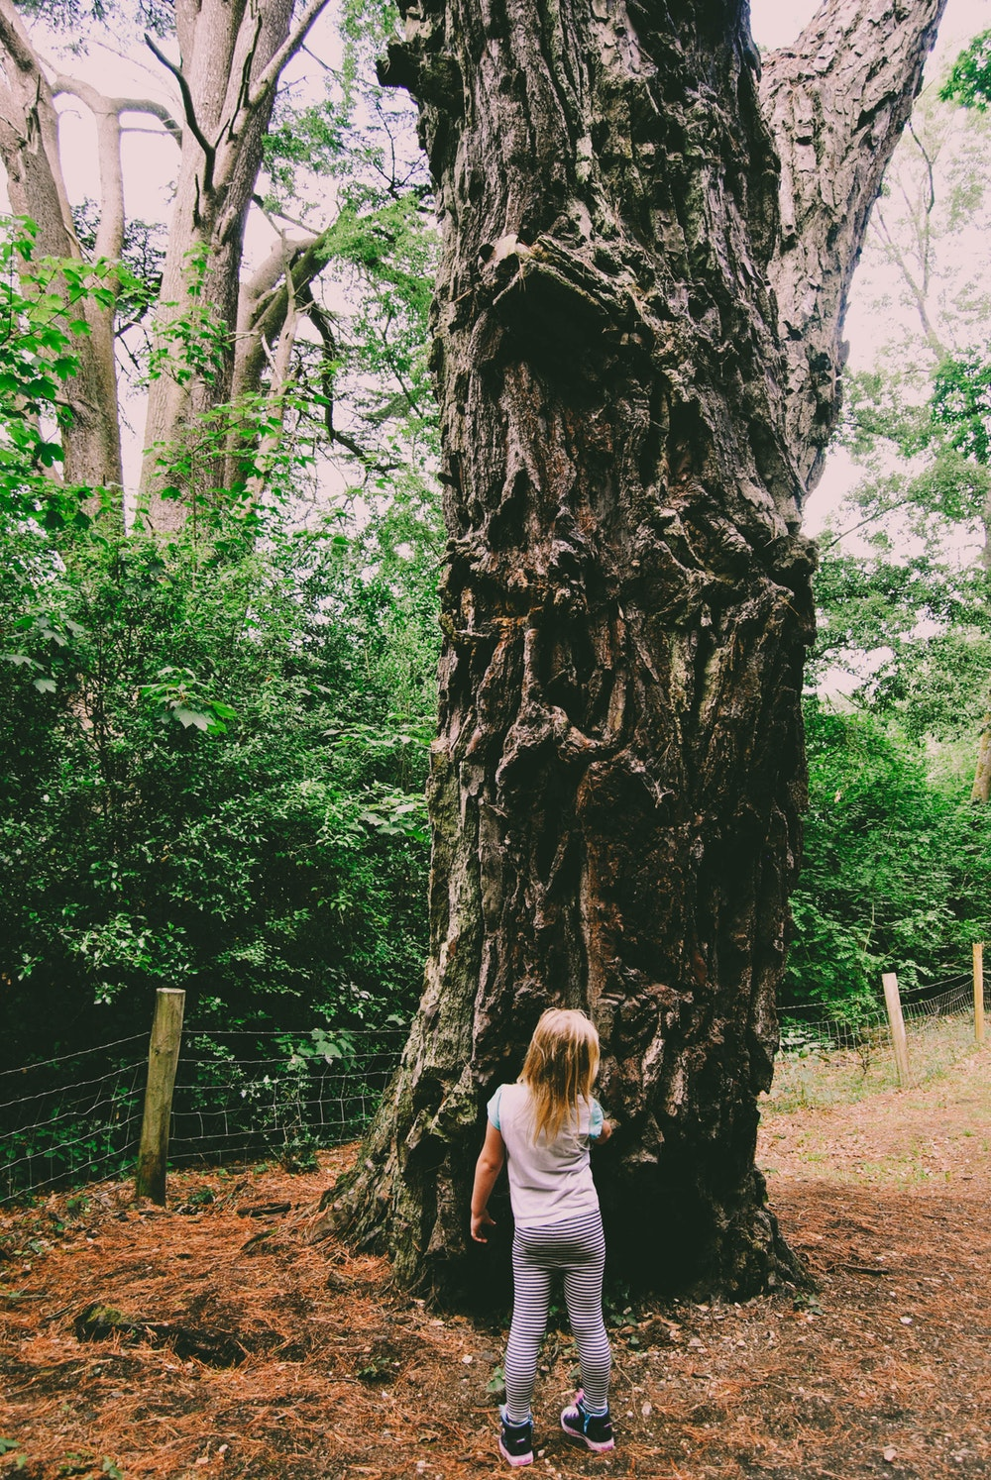
https://unsplash.com/photos/5ehGk97v1vo Rachel

